**Which Plant Where project**

## JULY 2018

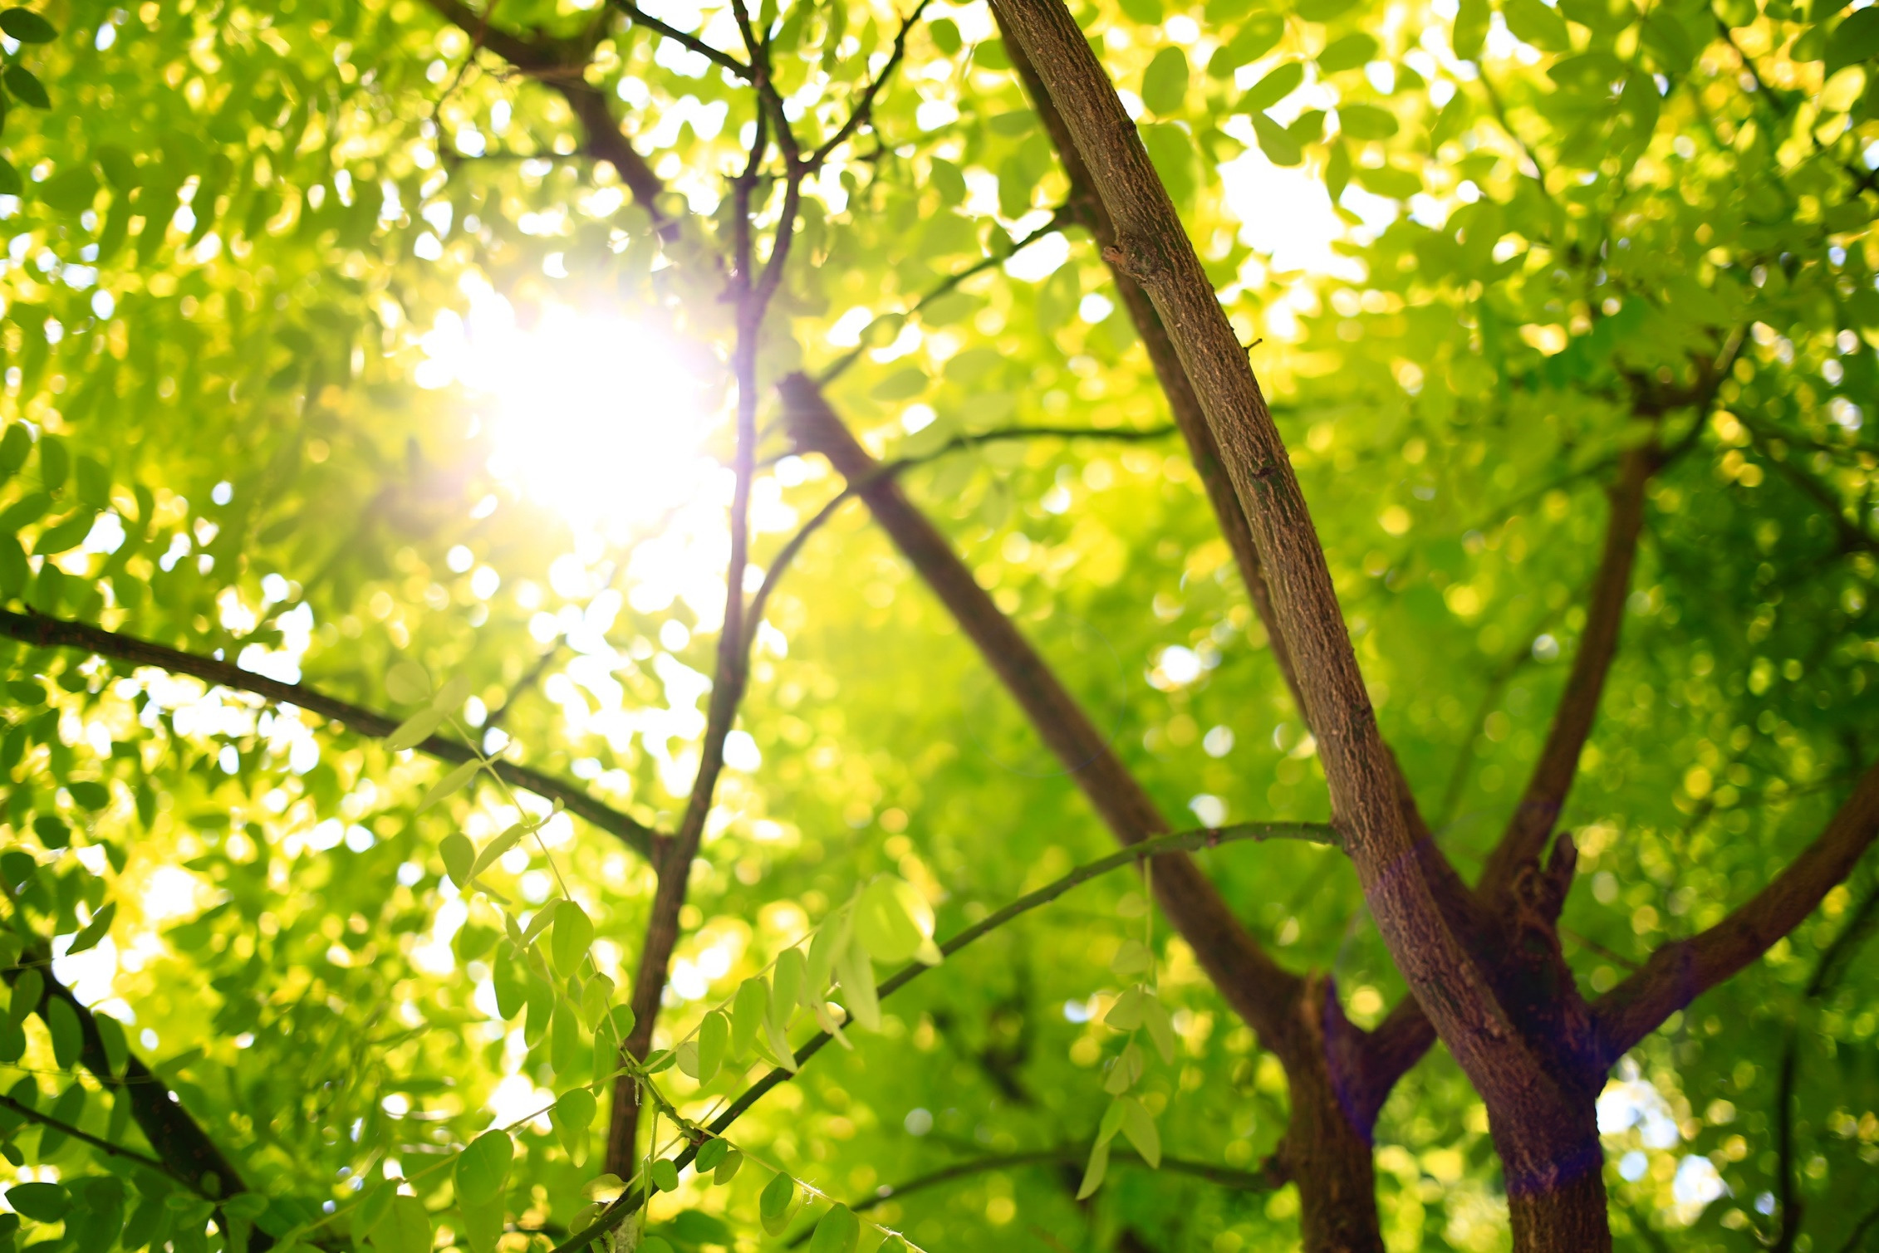

Prepared by Leigh Staas on behalf of the Which Plant Where project







## the wpw plant selection tool

The WPW project is creating an online plant selection tool which will enable practitioners to make more informed plant selections to support sustainable urban landscapes. The online tool will create market opportunities for growers by identifying native and exotic species in a variety of growth forms (trees, shrubs, climbers, grasses) that are resilient to climate change, for enhancing urban greening, thereby:

* Facilitating sustainable green cities in a changing environment
* Driving sustainable market growth for the horticultural industry
* Developing tools and resources to be used by a wide range of stakeholders

Some plants possess a greater capacity for resilience to the site specific conditions found in different urban greenspaces and their traits can guide end-users to a wide range of well-suited species. Once the site limitations are accounted for, the tool will leave end users free to choose plants based on aesthetic traits and functional benefits to optimise and customise the design of their particular urban green space. To start the conversation with our industry contacts, we have compiled a list of design elements and plant traits that seem relevant for the WPW plant selection tool. To construct the list, we:

* Analysed feedback from our stakeholder engagement
* Briefly reviewed site design considerations currently in practice from government guidelines, design textbooks and growers guides
* Reviewed 21 existing online plant selection tools from Australia and around the world to inform the search tool design and identify some possible features that may add to the tool’s utility.

REVIEWING PLANT SELECTION TOOLS

The most widely-used traits were those which tend to limit plant growth, such as Climate, Light Requirements, Tolerances/Hardiness and some measure of appropriate soil conditions. The distinguishing aesthetic qualities of the plant were also extremely common: Plant form, Colours, Height and Shape. Many plant selection tools selected plants based on appropriate locations, such as streets, gardens or parks or for other co-benefits such as “Bird attracting”.

Importantly, many other traits which were identified as integral to the success of plantings by stakeholders, were not commonly used to select plants. These included Maintenance Requirements, Planting problems or Dangers associated with the species. The lack of popularity may be due to the difficulty in defining some of these traits meaningfully. For example, it may be difficult to determine what constitutes a “high maintenance” plant, as this may depend on many other factors and is a dynamic trait over the lifetime of the plant.

Subjective but important traits such as Maintenance Requirements are an area which can be improved with our tool and really address a number of issues raised in the stakeholder engagements.

Although warnings and appropriate maintenance regimes were often recommended in the results of the search, this could be a cumbersome way to rule out unsuitable species and may result in oversights during the selection process.

THE PLANT TRAIT DATABASE

The WPW traits database is an ongoing, iterative process as we continue to engage with stakeholders and draw on literature. We are currently collecting the following plant trait data from scientific institutions, botanic gardens, horticulturalists, industry professionals and nurseries:

TOWARDS A MORE SOPHISTICATED AND USER-FRIENDLY PLANT SELECTION TOOL

Even at this early stage, we thinking forward about how best to use the data. Key traits can be used as selection criteria for planting in a specific kind of urban site. For example, the CITree database designed by a German research team uses the following traits to select appropriate plants for playgrounds, traffic areas and parks in Europe (Vogt, Gillner, et al., 2017).

|  |  |  |  |
| --- | --- | --- | --- |
| **Trait** | **Traffic Areas** | **Children's Playground** | **Parks/Gardens/Cemetaries** |
| Drought tolerance | Medium or High |  |  |
| Heat tolerance | Medium or High |  |  |
| De-icing salt tolerance | Medium or High |  |  |
| Soil compaction tolerance | Medium or High | Medium or High | Medium or High |
| Pollution tolerance | Medium or High |  |  |
| Allergenicity | Low | Low | Low |
| Invasive roots | Non-invasive |  | Non-invasive |
| Limb breakage risk | Low | Low | Low |
| Toxicity | Low | Low |  |
| Fruitfall | No |  | No |
| Pollinator attracting |  | Yes | Yes |
| Bird attracting |  | Yes | Yes |
| Spines and thorns |  | No |  |
| Unpleasant odour |  |  | No |
| Edible products |  | Yes |  |
| Native species |  | Yes |  |

There are numerous other examples of assessment criteria we can draw on to select appropriate urban tree species. McPherson et al (2018) suggests a list of key traits to improve urban forest species selection in California. It includes Soil Texture and pH, Soil Moisture, Sunlight Exposure, Drought Tolerance, Salt Tolerance, Wind Tolerance, Cold Hardiness, Invasiveness and Pests and Disease Risk (McPherson, Berry, et al., 2018).

The Tree Selection Matrix for the City of Melbourne (Urban Forest Strategy, 2011) uses Longevity, Maintenance level, Litterfall and Shade Tolerance in addition to the criteria mentioned above. In their design, industry professionals rated tree species’ key traits on a scale of 1 to 5. The scores were added and the total used to assess the suitability of species to different urban environments such as footpaths, laneways and median strips.

Currently, we are collecting species information for all of these key decision-making traits, as well as the many functional and aesthetic qualities of plants that are employed in the design of urban green spaces.

However, some challenges remain in obtaining the required data...

QUESTIONS

* How to document the plant traits for new and high performing cultivars as they enter the market
* How to integrate local species planting lists from councils with our national database
* How to approach the issue of quantifying maintenance
* How to access better data for depth/required soil volume

## References

McPherson, E.G., A.M. Berry and N.S. van Doorn. 2018. Performance testing to identify climate-ready trees. Urban Forestry & Urban Greening 29: 28-39.

Urban Forest Strategy, C.o.M. 2011. Urban Forest Diversity Guidelines. Tree Species Selection Strategy for the City of Melbourne. City of Melbourne, Melbourne.

Vogt, J., S. Gillner, M. Hofmann, A. Tharang, S. Dettmann, T. Gerstenberg, et al. 2017. Citree: A database supporting tree selection for urban areas in temperate climate. Landscape and Urban Planning 157: 14-25.